Step 1🡪 Naming test plan as jdbc sampler test plan.

Step 2🡪Right click on test plan ,click on the thread and select thread group

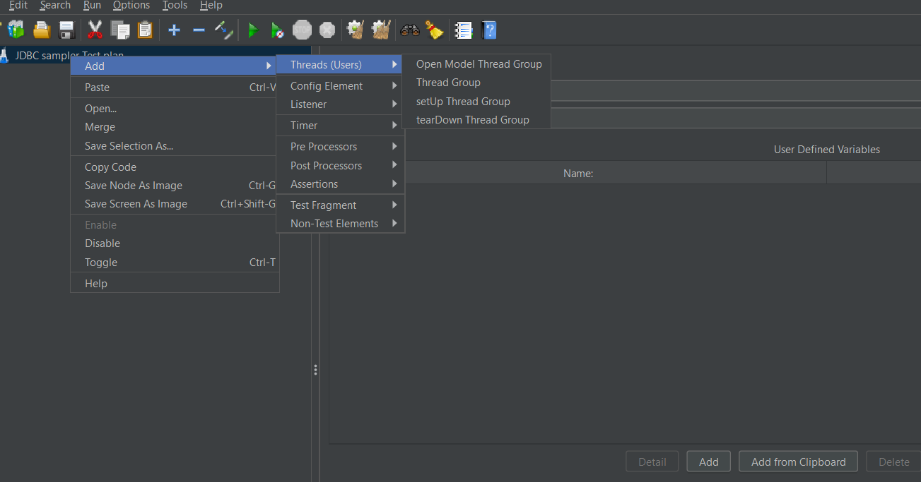

Step 3 -adding listener (view result tree)

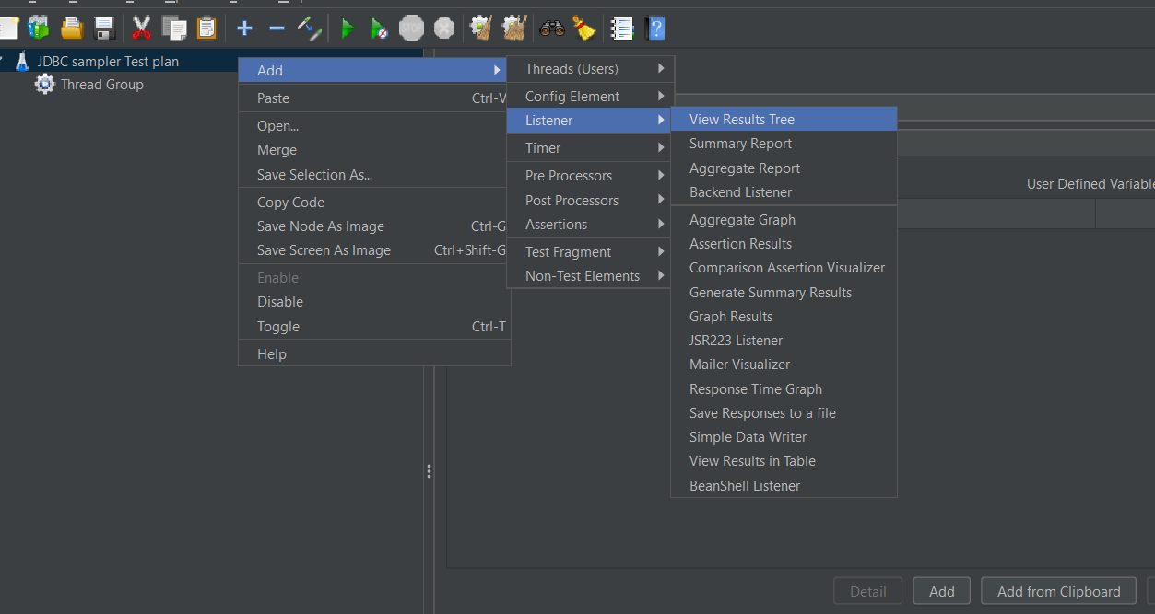

Step 🡪4 right click on the thread group ,click on add,click on the config element and click on the jdbc connection configuration.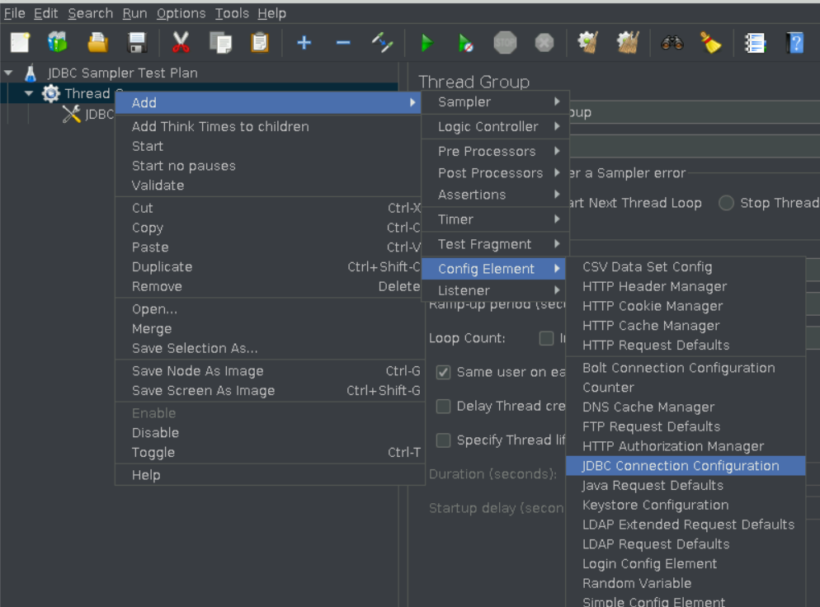

Step 5🡪 Right click on the Thread Group and click on add and click on sampler and click on jdbc request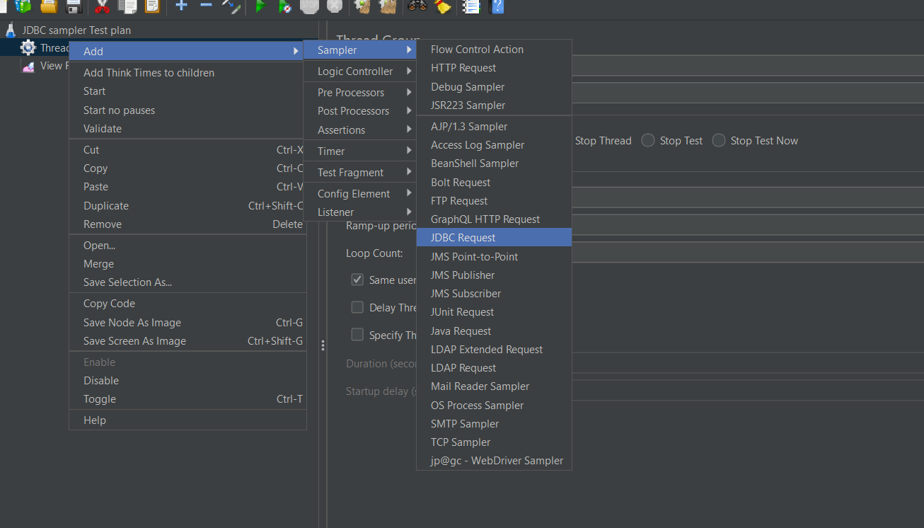

Step 6🡪in jdbc connection configuration

Giving variable name for created pool ==dbpool

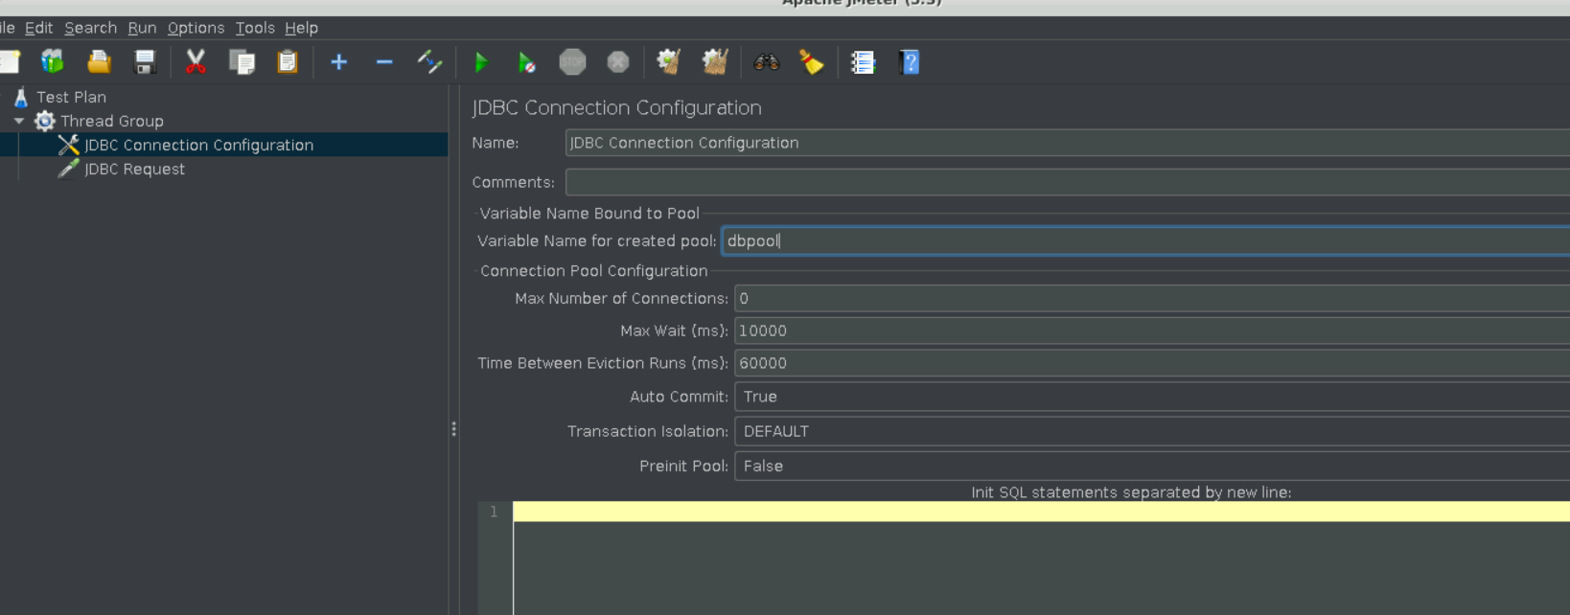

Step 7🡪 In Database Url =jdbc:mysql://localhost:3306/animated_movies

Jdbc Driver class=com.mysql.cj.jdbc.Driver

Username –root

Password-root

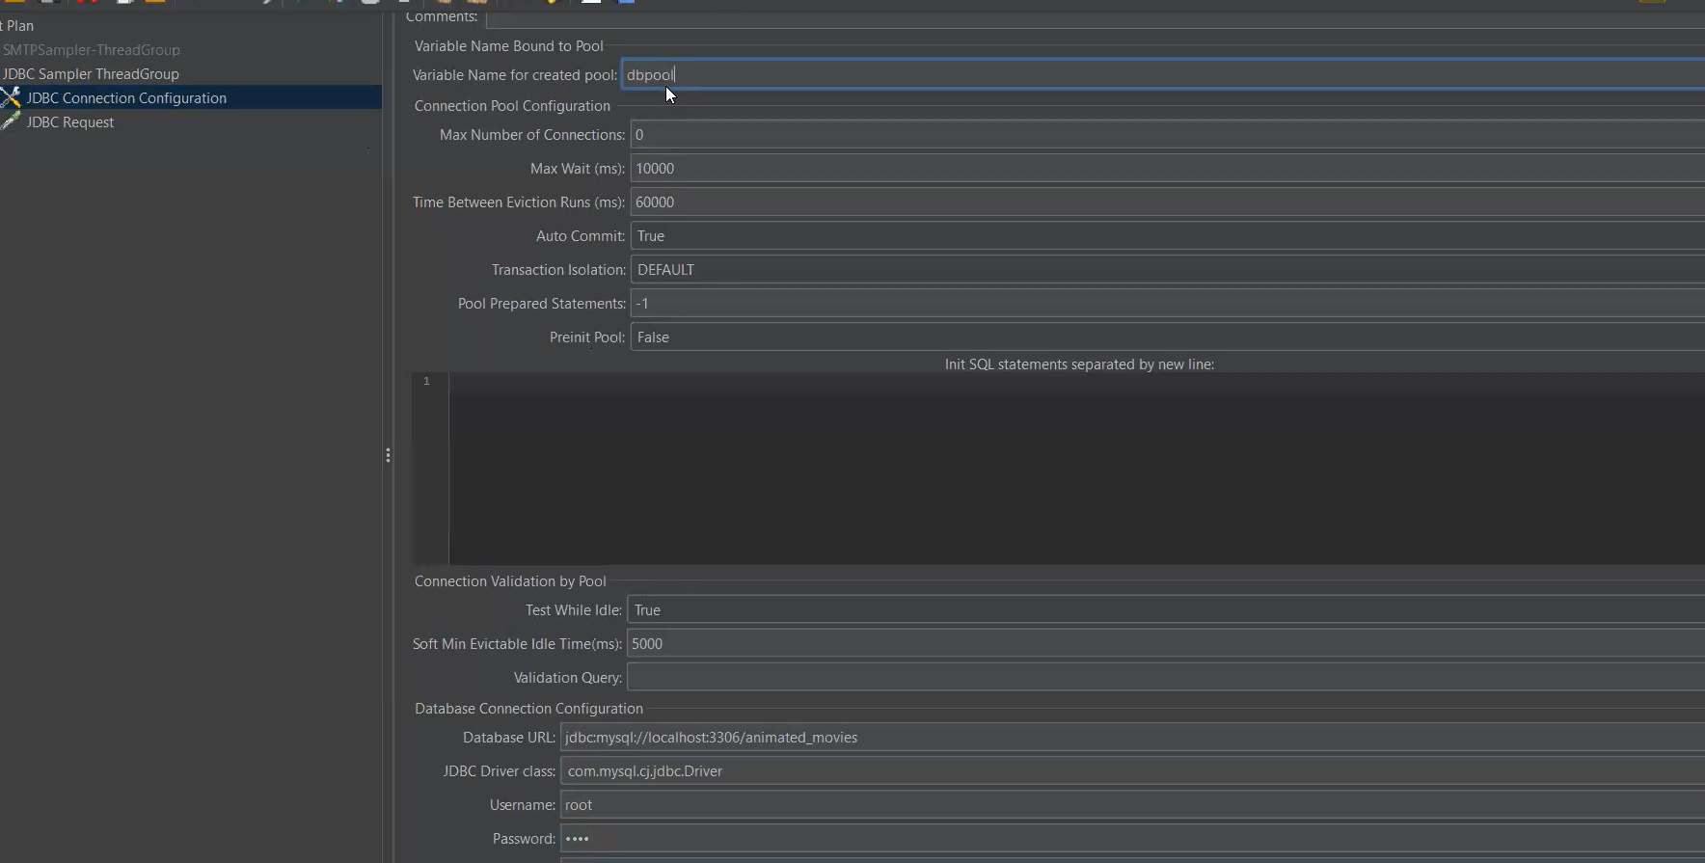

Step8:- in jdbc request

Select * from movies;

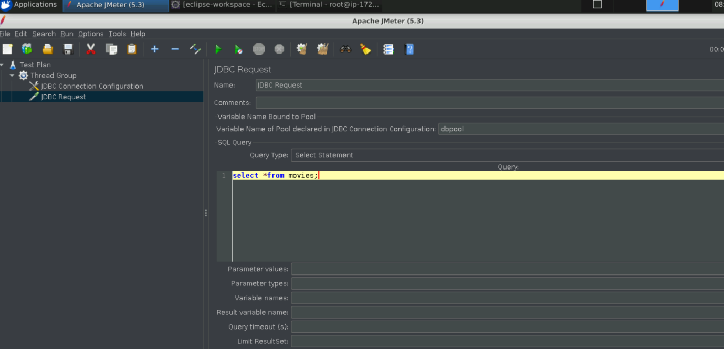step🡪 Add listener and click on run